The Seasons on Earth
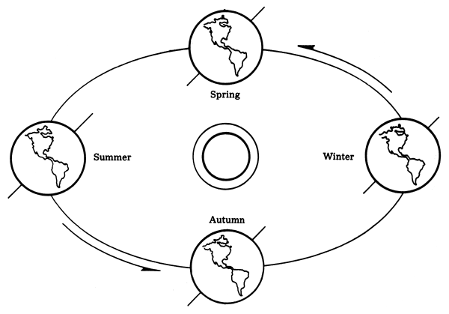
The Earth's seasons are not caused by the differences in the distance from the Sun throughout the year (these differences are extremely small). The seasons are the result of the tilt of the Earth's axis.
The Earth's axis is tilted from perpendicular to the plane of the ecliptic by 23.45°. This tilting is what gives us the four seasons of the year - spring, summer, autumn (fall) and winter. Since the axis is tilted, different parts of the globe are oriented towards the Sun at different times of the year.

